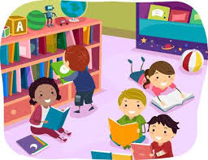
PTA book fair will be the week of November 11. Library and guidance classes will be in the story pit.

Kindergarten classes will be exploring familiar traditional stories such as The Three Little Pigs, Goldilocks, and The Three Billy Goats Gruff. We will read the traditional story as well as fractured tales. Students will begin to make connections between stories.

First Grade classes will be doing a Guided Inquiry unit on Characters in the Library. They will explore different characters through the lens of friendship. We will read many different books that have a friendship theme. At the end of the unit students will create a new character for their favorite story.

Second Grade classes will continue exploring nonfiction books to discover topics of interest. We will read A Dog Wearing Shoes to practice inferring character’s feelings.

Third Grade classes are learning about folklore. They have explored the many different folklore books that we have available in the library. We will connect culture knowledge to an atlas. We will read Martina the Beautiful Cockroach and use an Atlas to see where the story takes place. Students will identify a book they enjoy and practice using a print atlas to find the setting.

Fourth grade classes are continuing to be curators of photography to showcase their learning about Virginia’s geographic regions. We then begin learning how to become better and wiser information consumers and producers. We will read But I read it on the Internet and look at a series of fake and real information websites to practice web evaluation skills.

Fifth Grade classes will explore the Cavendish Square database. They will look at: Ancient & Medieval World”, “Exploring Ancient Civilizations”, and/or “God, Goddesses, & Mythology”.

Please let me know if there is anything that you would like me to focus on to help you in your lessons.

